CNNP- Skill 2

NAME: P.BINDHU MADHAVI
ROLL NUMBER: 2520030077
SEC: 4

1.Install tools

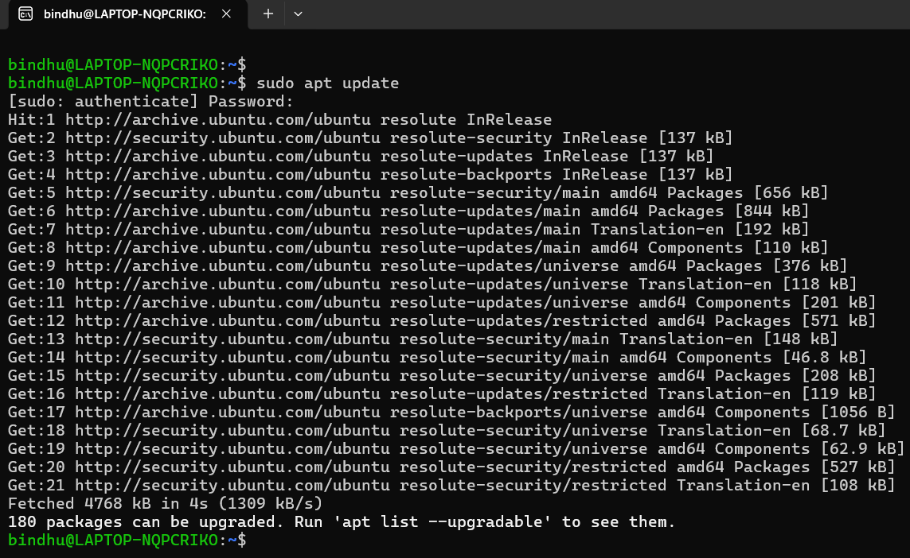
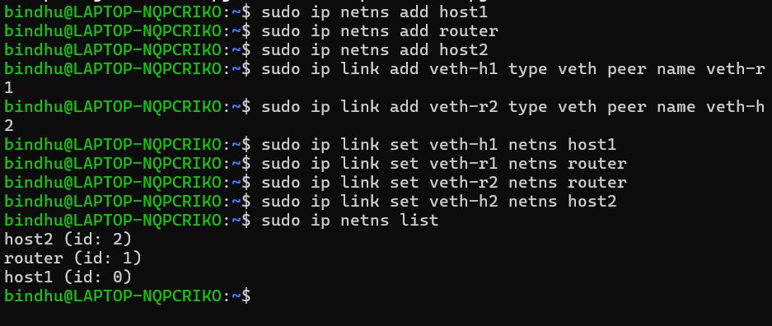

2.Configure IP addresses

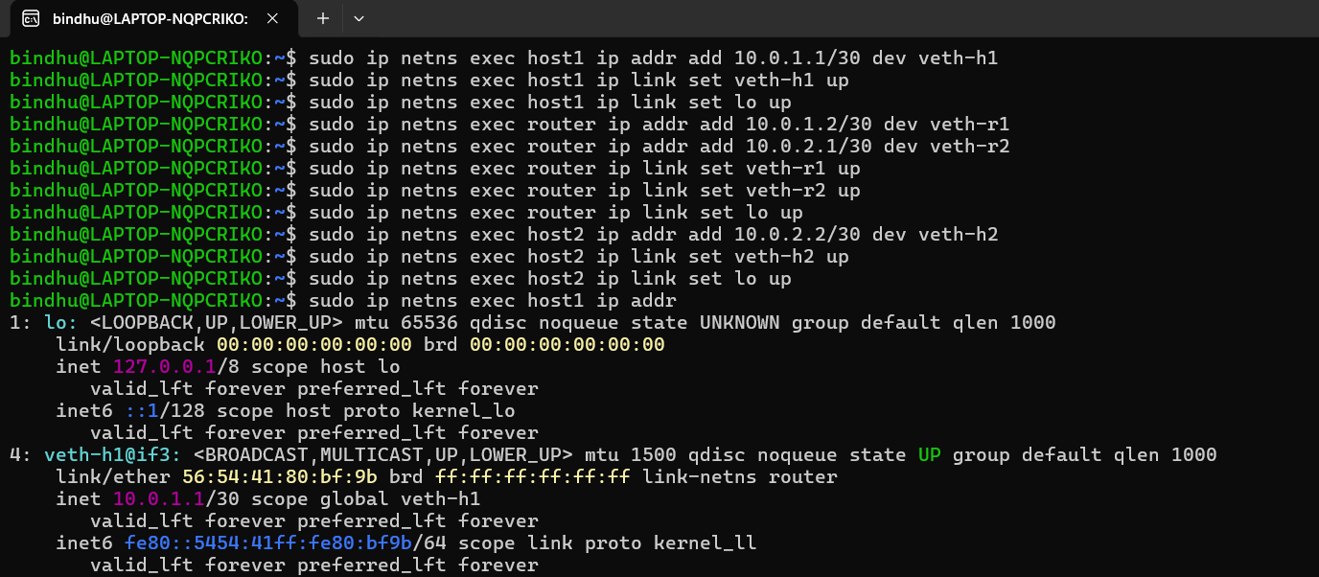

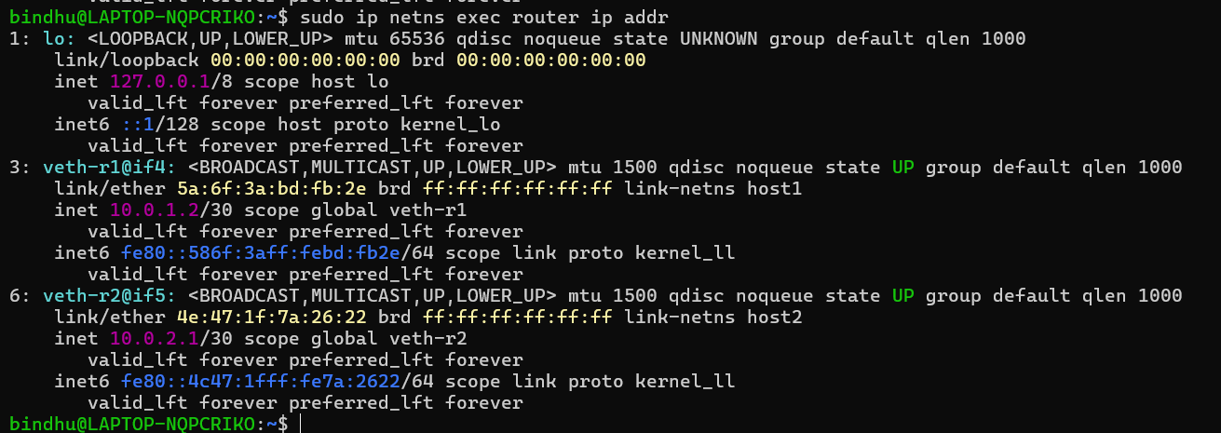

3.Enable routing and Test connectivity

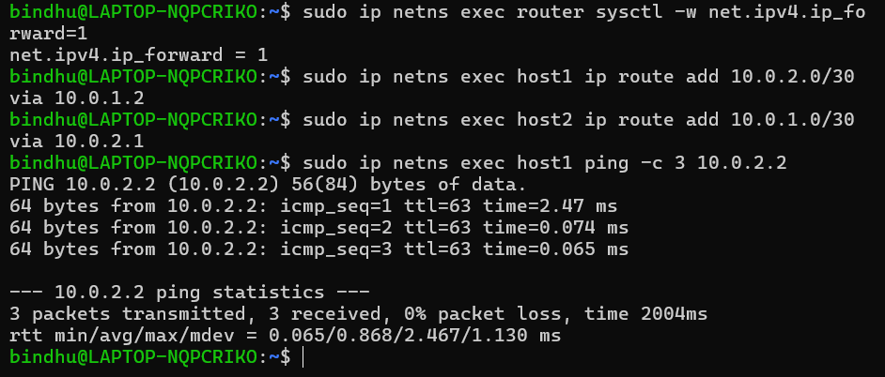
4. Add delay and packet loss
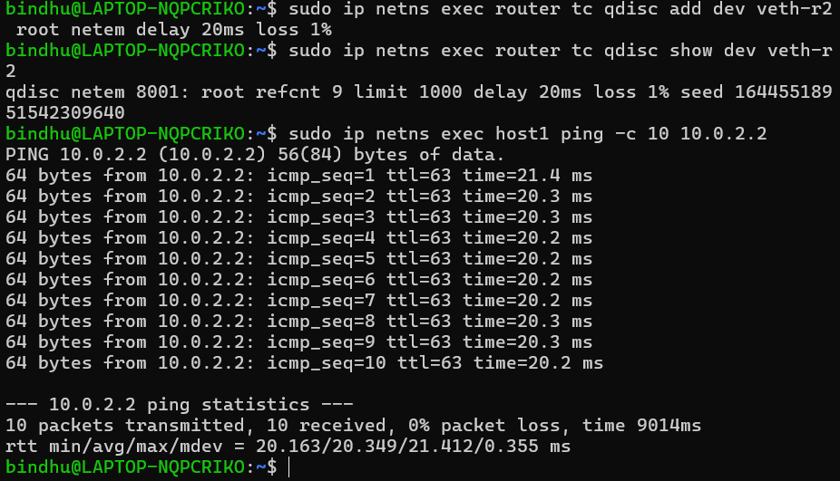

5.Open four terminals

Terminal 1 : Host1 capture
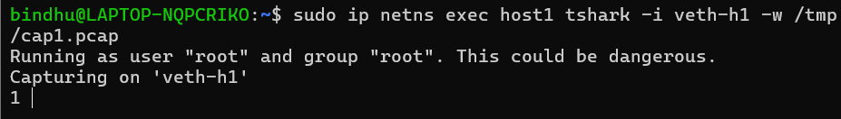
Terminal 2 : Router capture
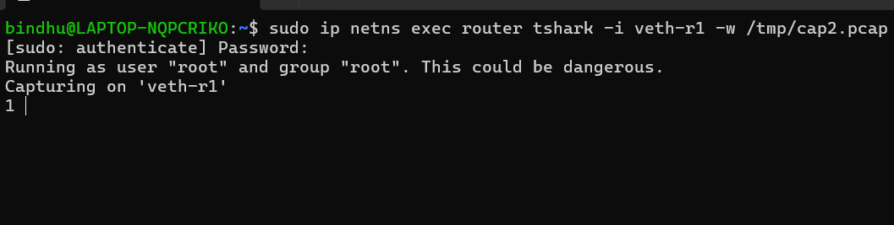
Terminal 3 : Host2 capture
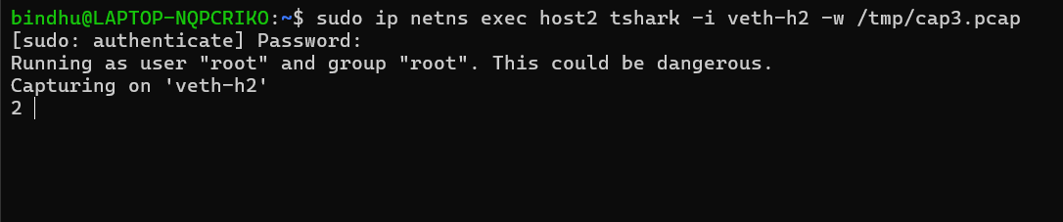
Terminal 4
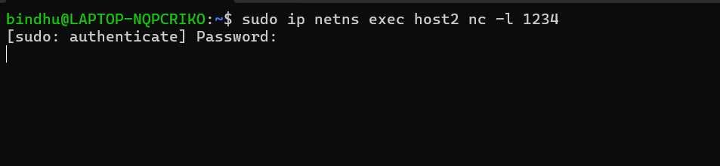
Terminal 5: Connect Host1 to Host2 and Type the following messages

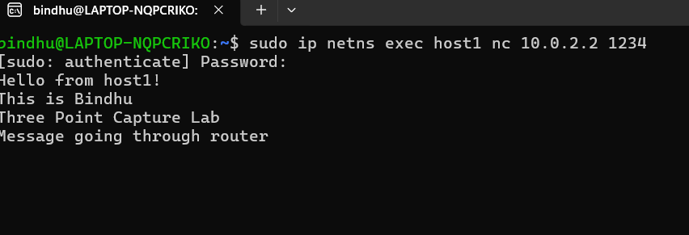Terminal 4: Go back to Terminal 4
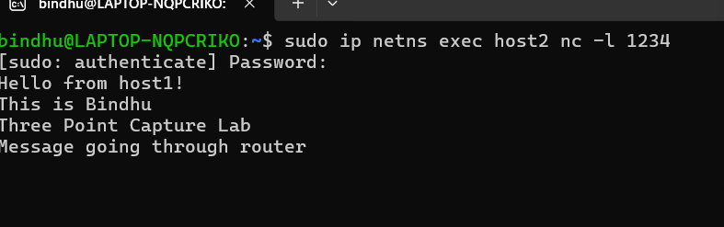

6. Stop packet captures and Fix permissions

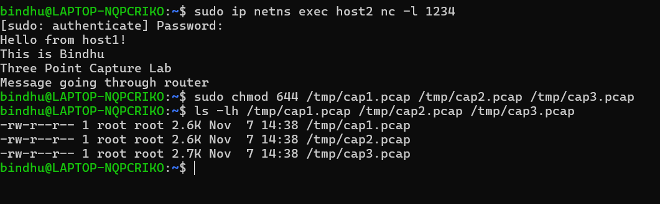

7. Check TTL

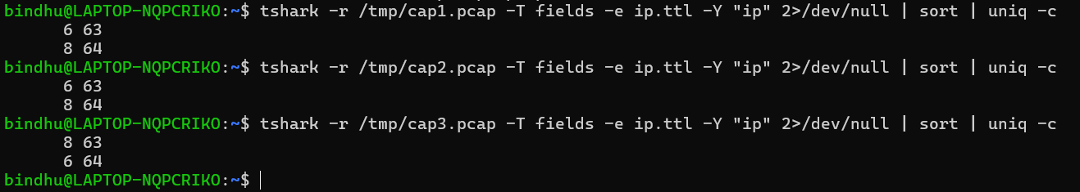

8. Check network delay , Check retransmissions and Check RTT

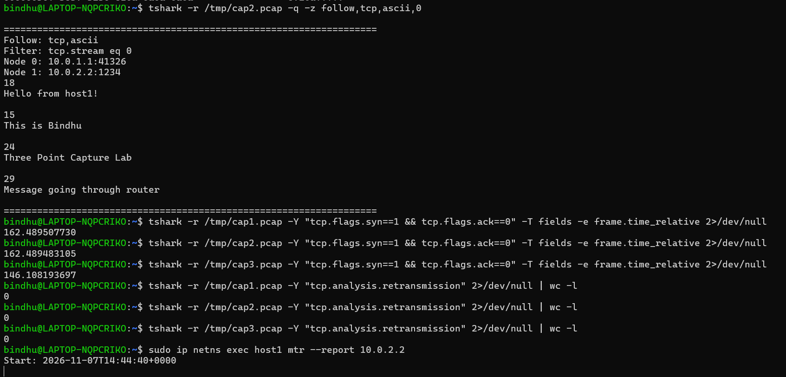

9. Open Wireshark
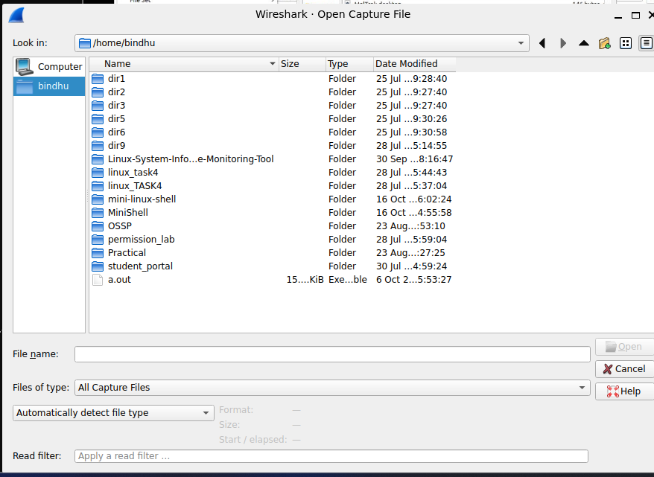

10. Apply the filter

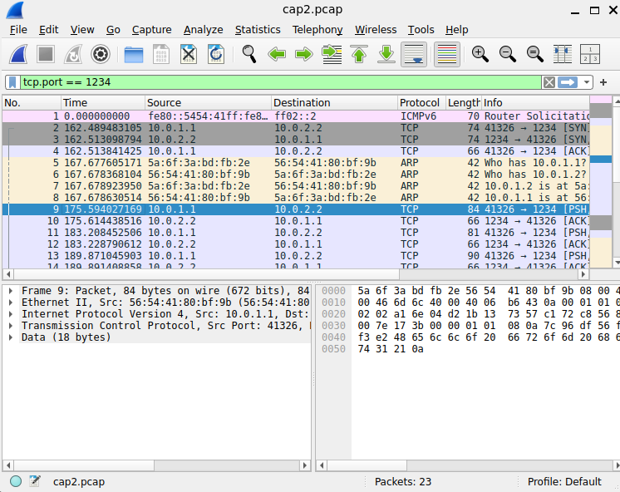

11. Inspect a packet

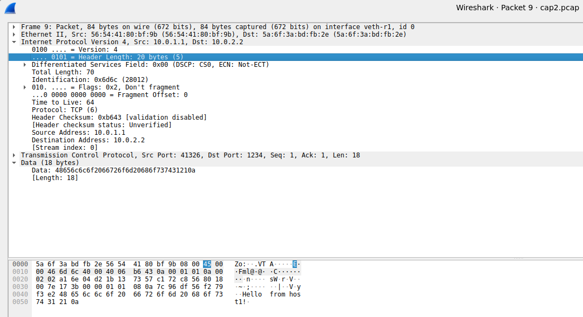

12. Add TTL column
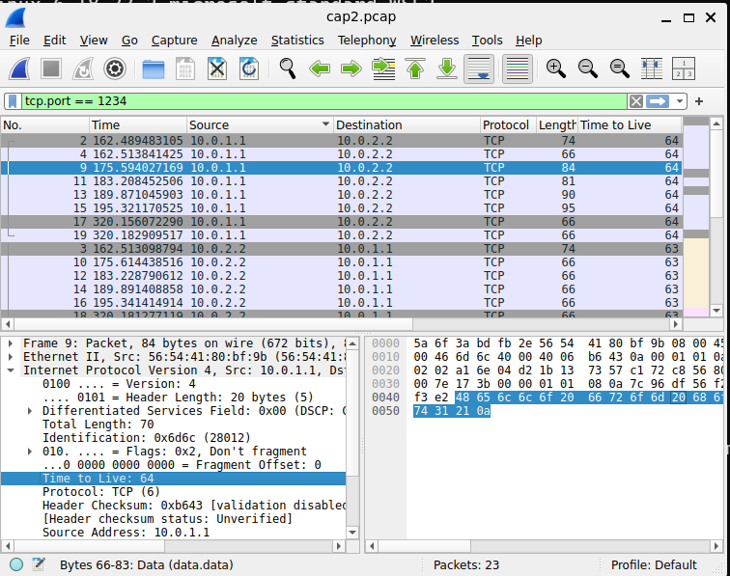
13. Final cleanup


